**Source Code**

Contents

1. Image 1. 3

2. Image 2. 4

3. Image 3. 5

4. Image 4 6

5. Image 5. 7

6. AWS management console: 7

7. Img: 8

8. Img: 8

9. Img: 9

10. Img: 9

11. Img: 10

12. Command prompt: 10

13. Jenkins: 11

14. Unlock Jenkins: 11

15. Customize: 12

16. Create: 13

17. Docker: 14

18. Docker 2: 15

19. Jenkins details: 16

20. Backend: 16

21. Global Tool Configuration: 17

22. Pipeline: 18

23. Triggers: 18

# Image 1.

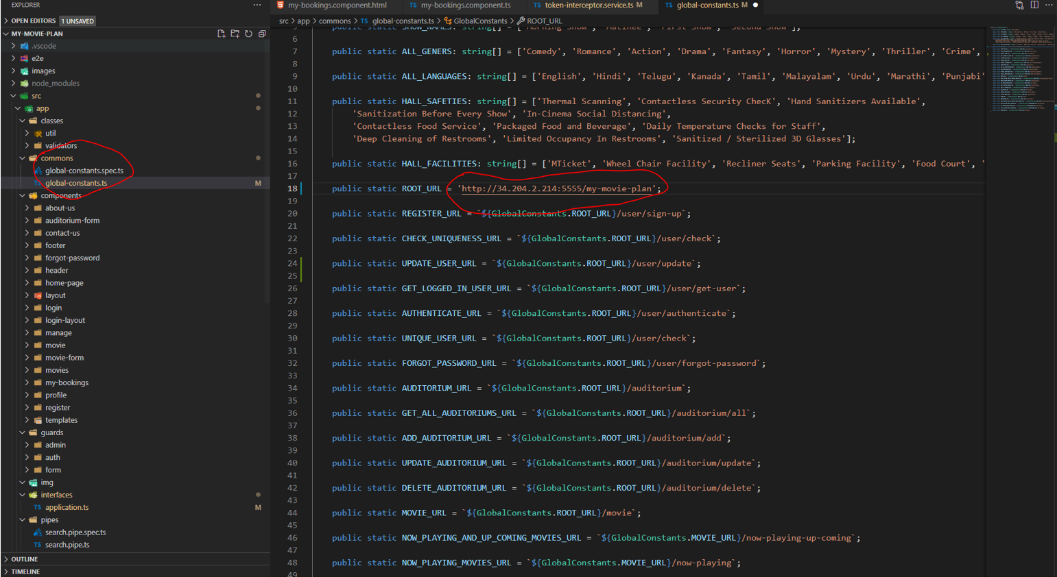

# Image 2.

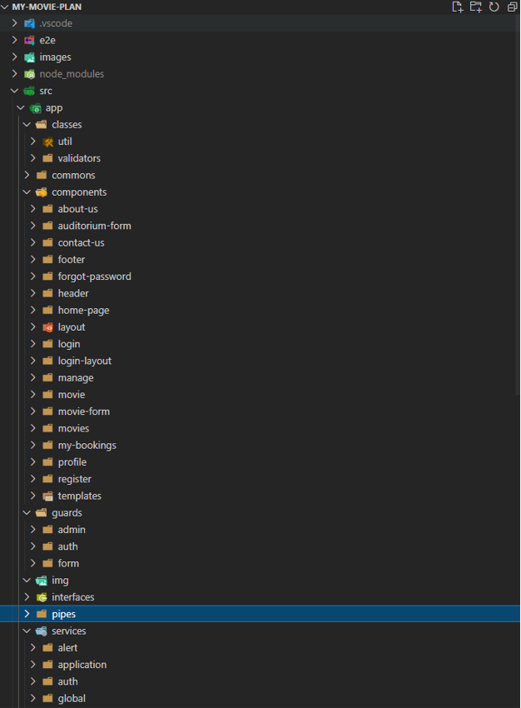

# Image 3.

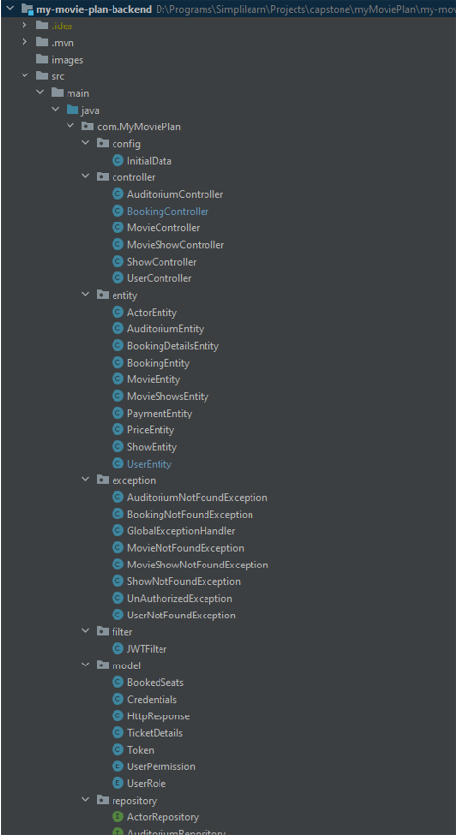

# Image 4

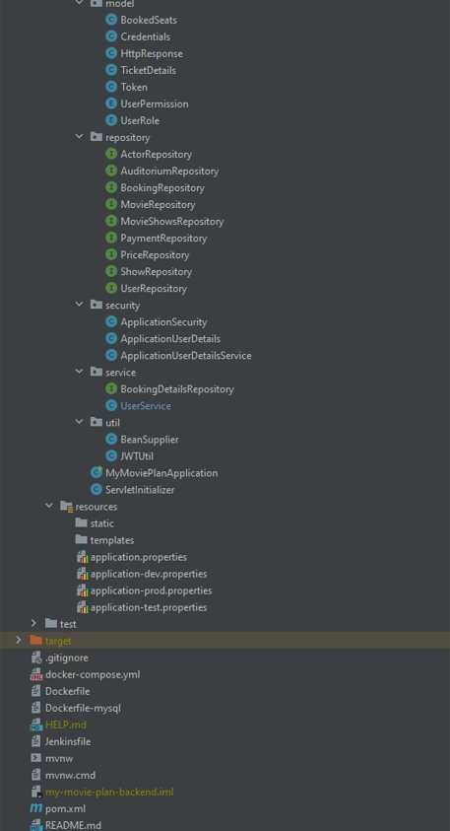

# Image 5.

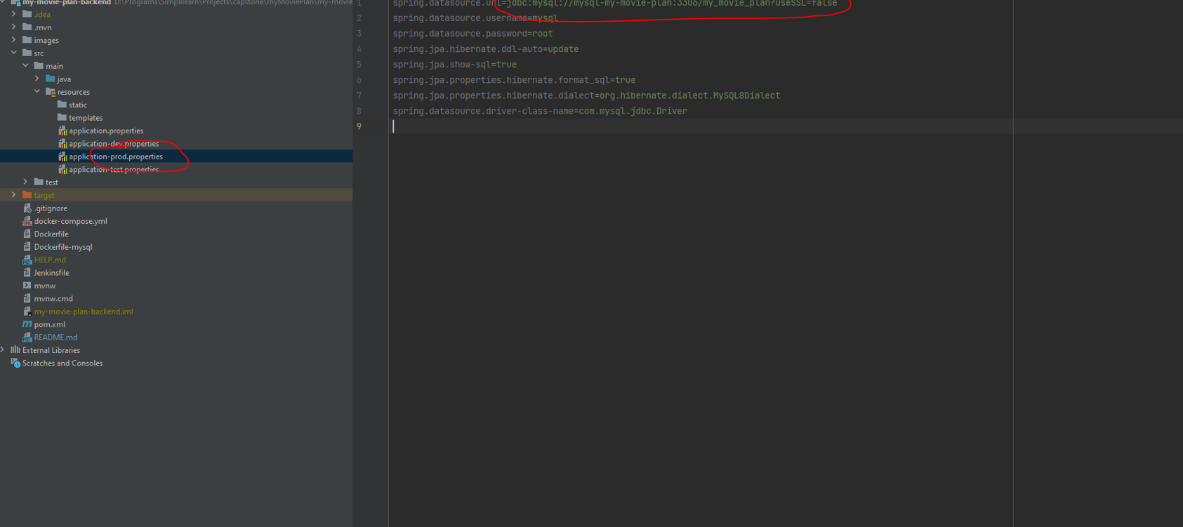

# AWS management console:

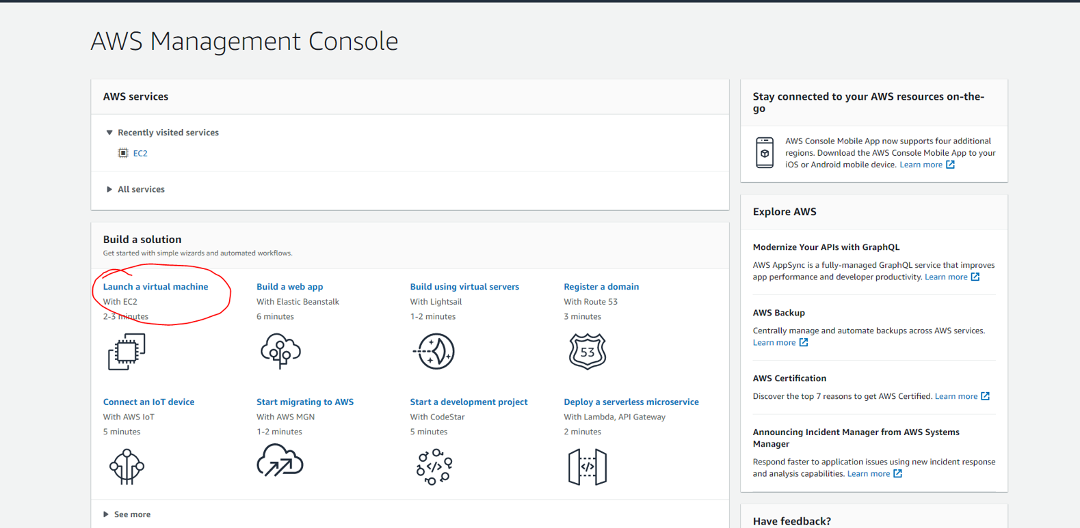

# Img:

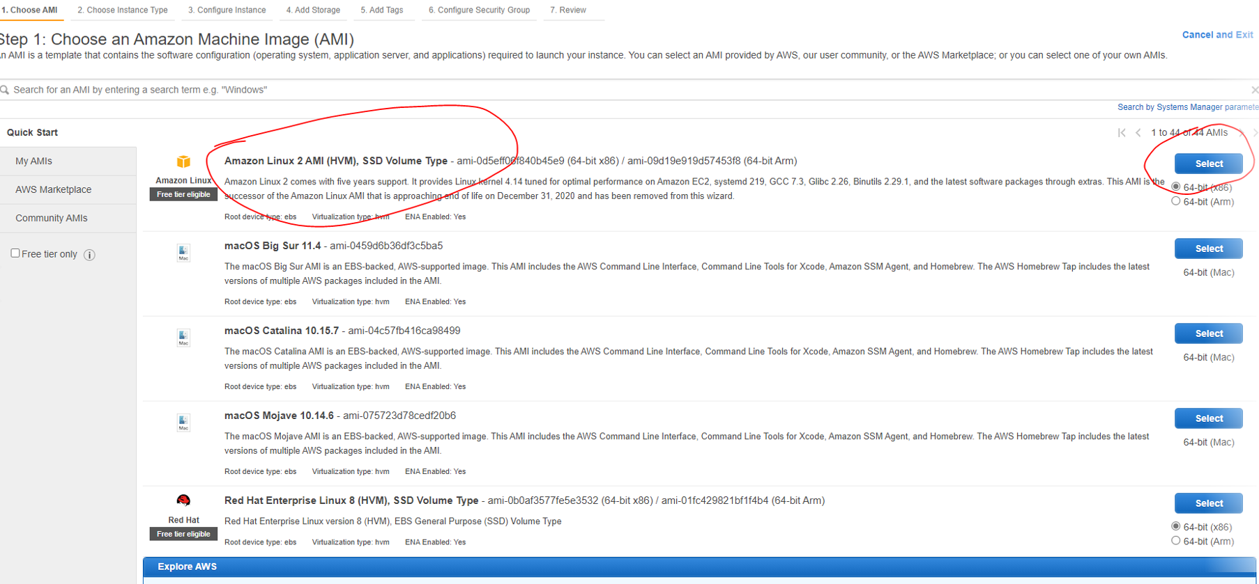

# Img:

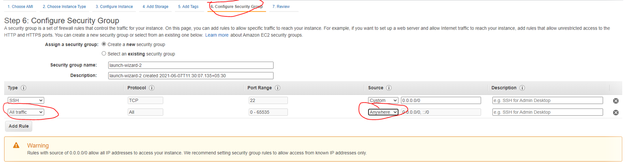

# Img:

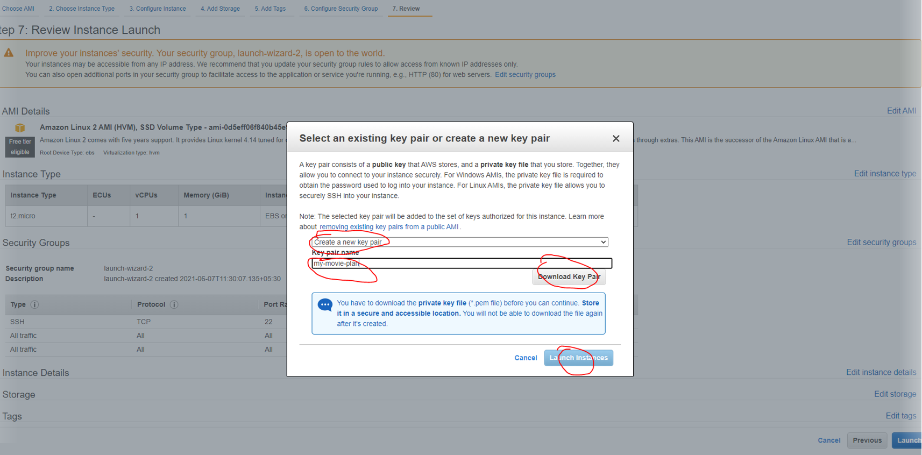

# Img:

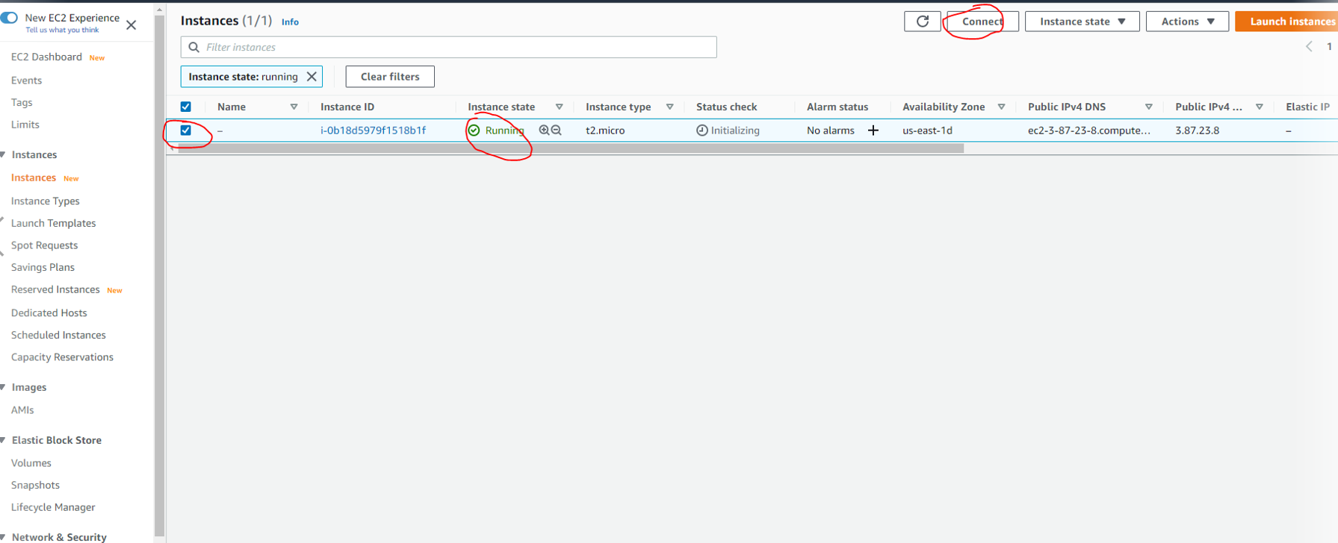

# Img:

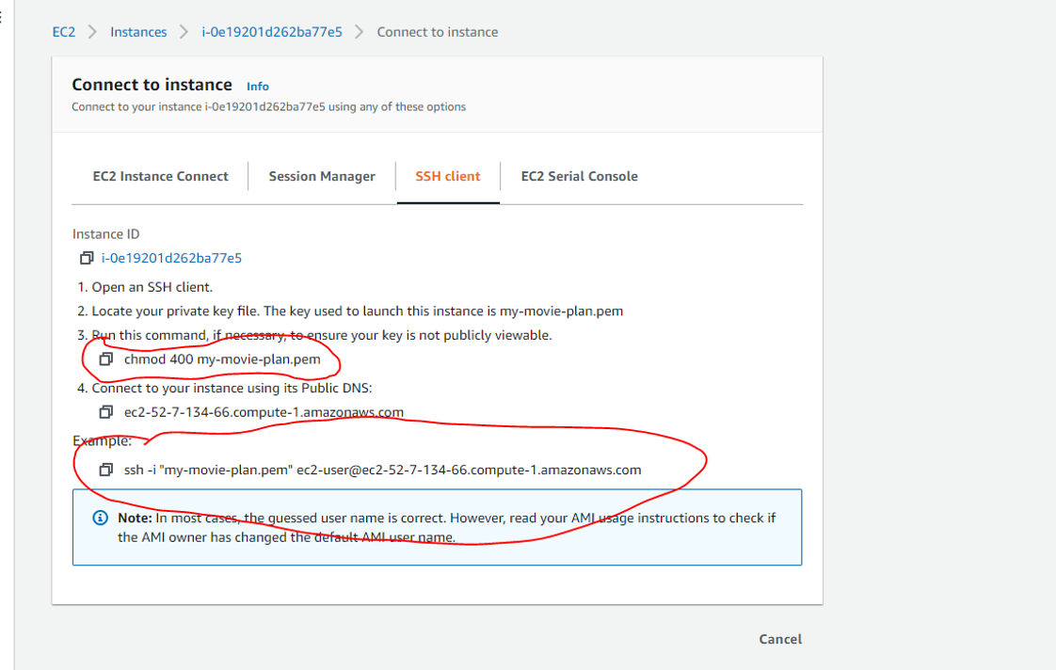

# Command prompt:

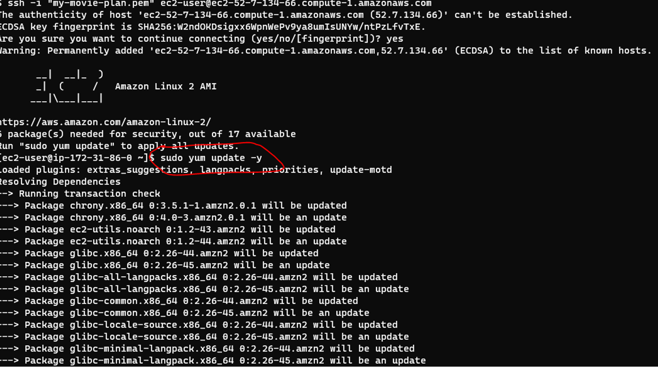

# Jenkins:

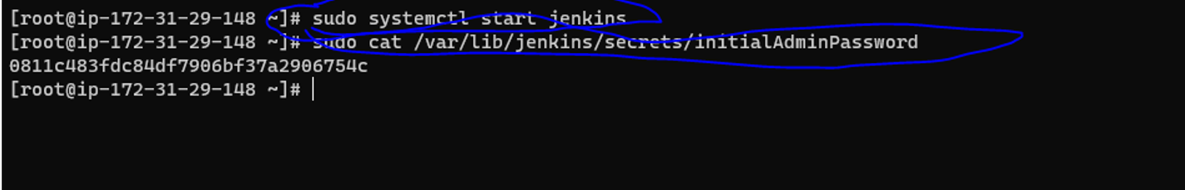

# Unlock Jenkins:

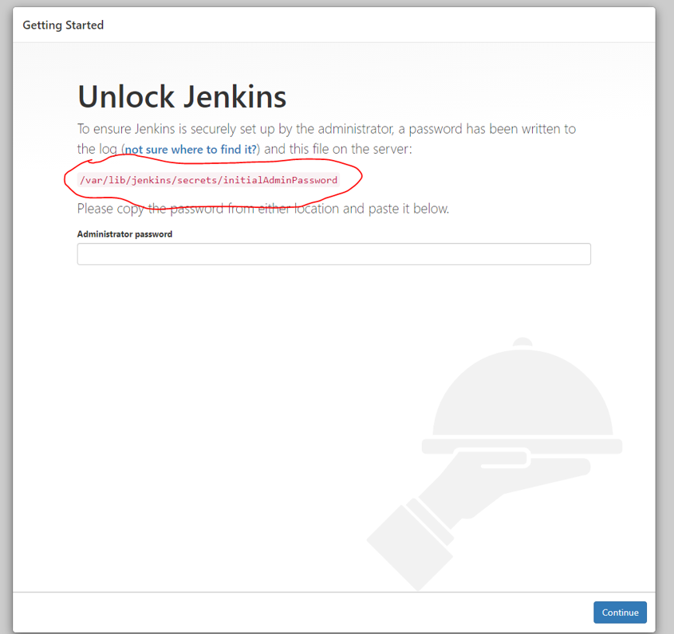

# Customize:

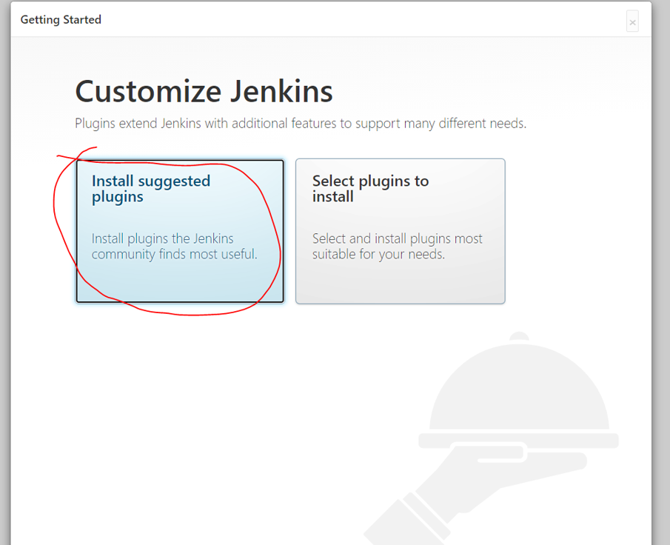

# Create:

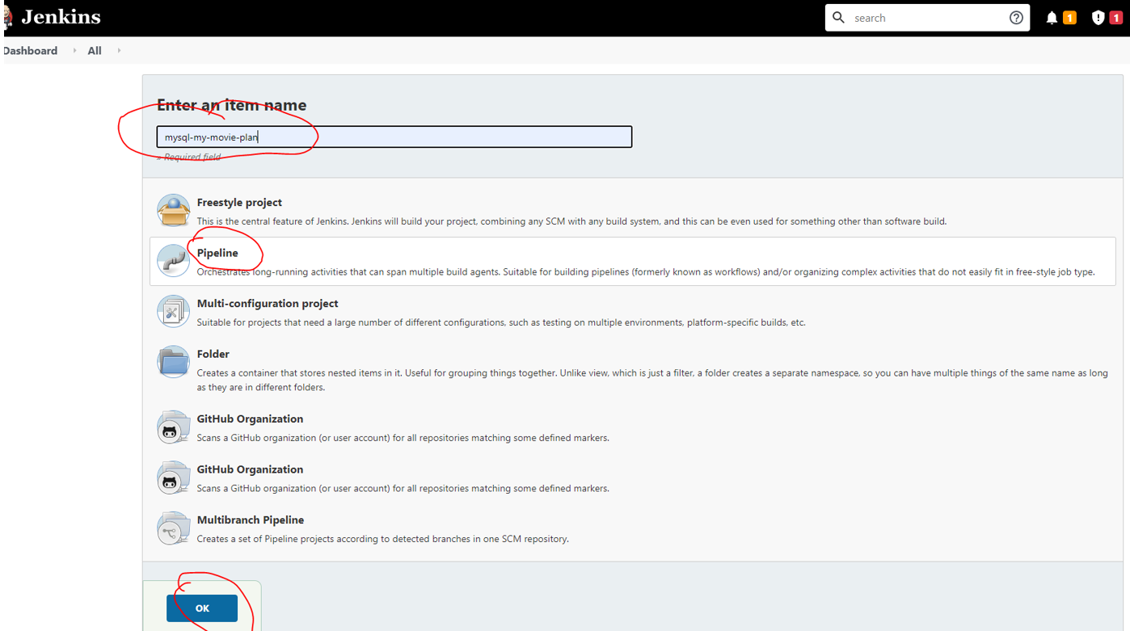

# Docker:

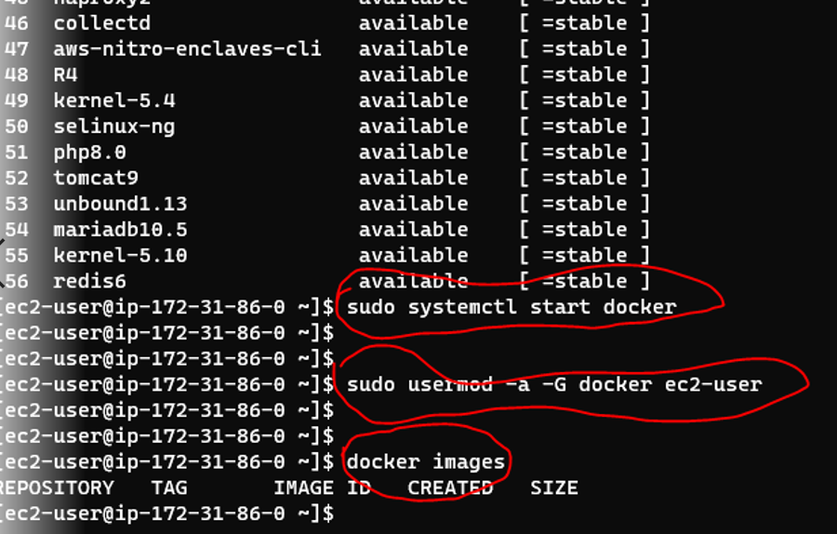

# Docker 2:

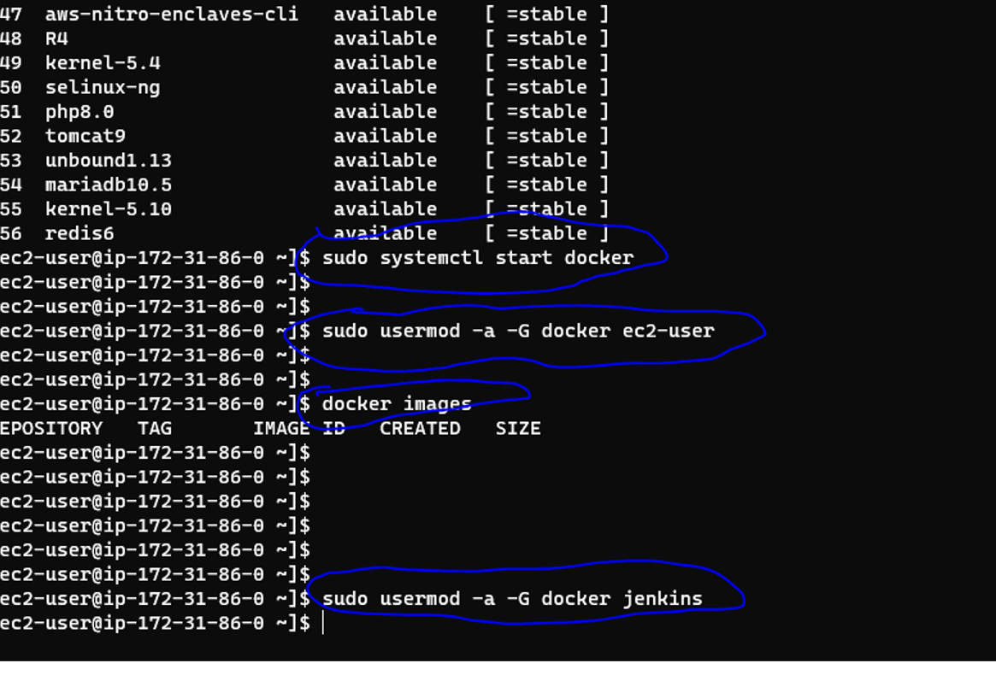

# Jenkins details:

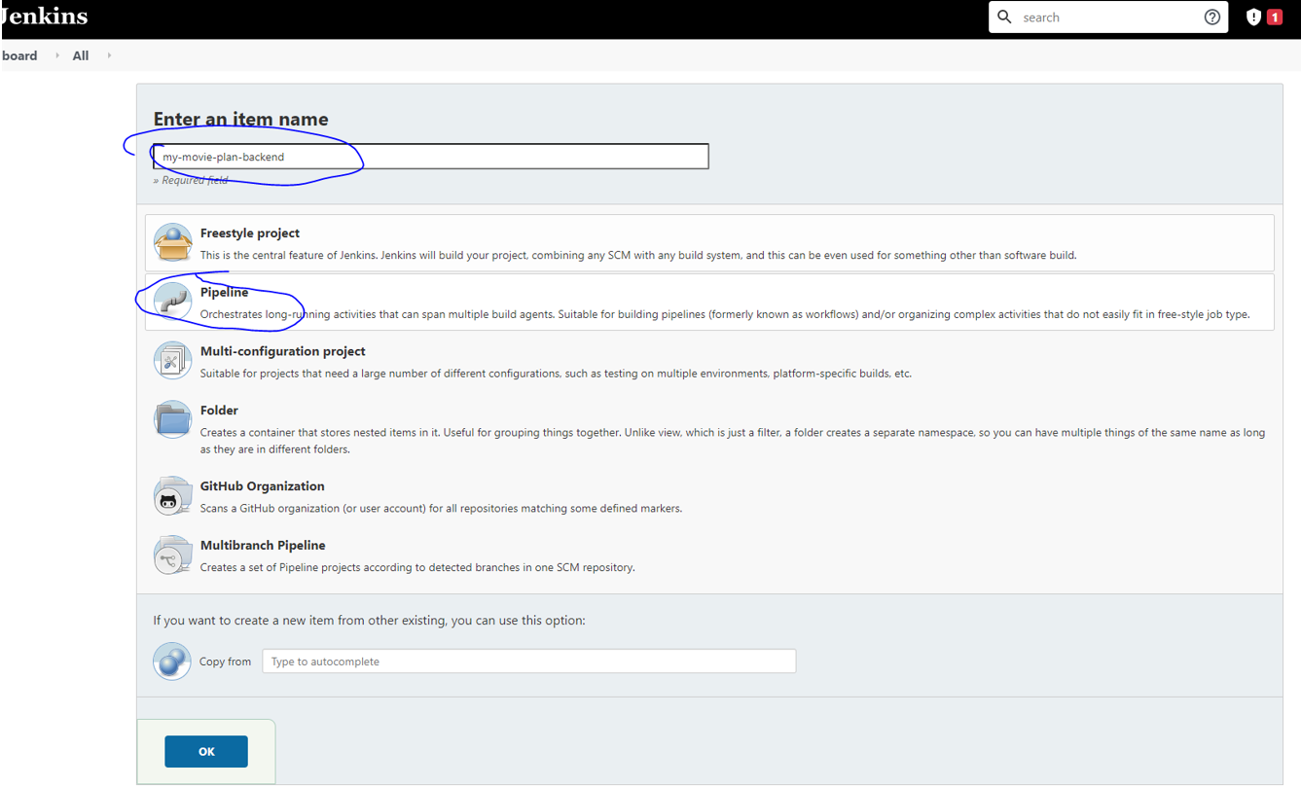

# Backend:

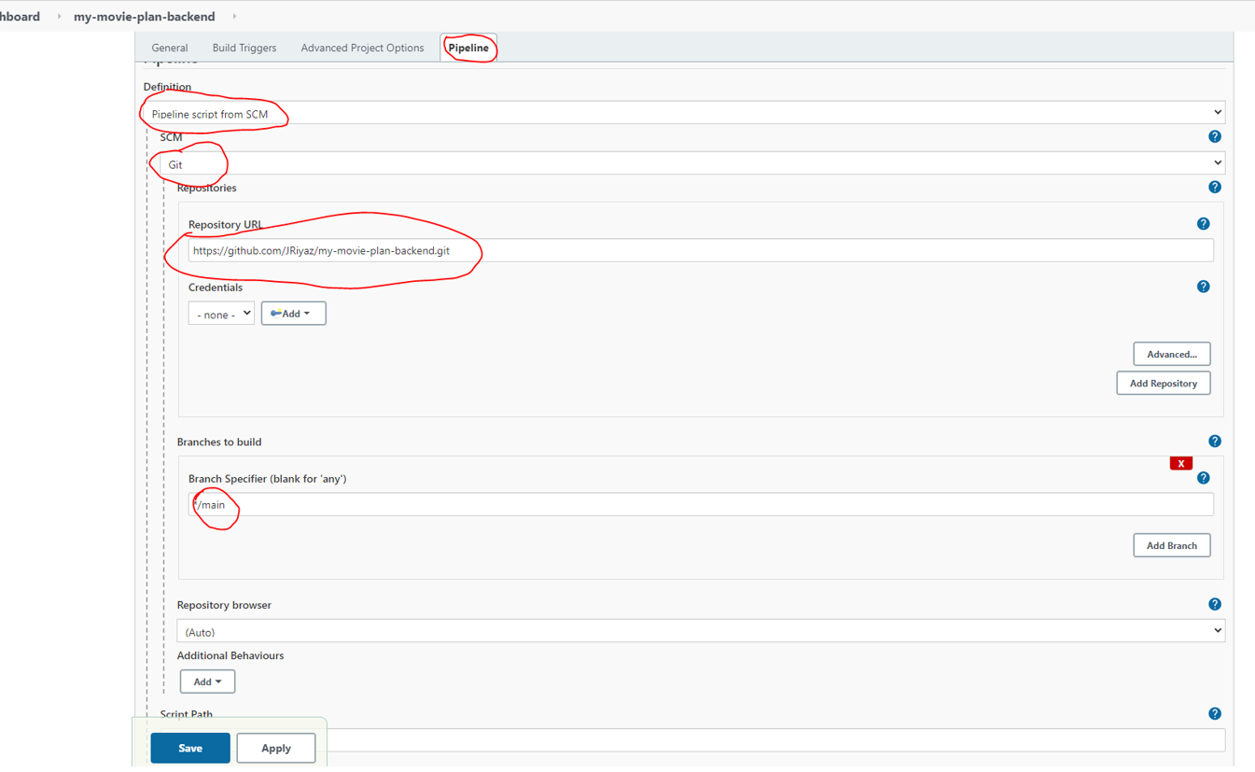

# Global Tool Configuration:

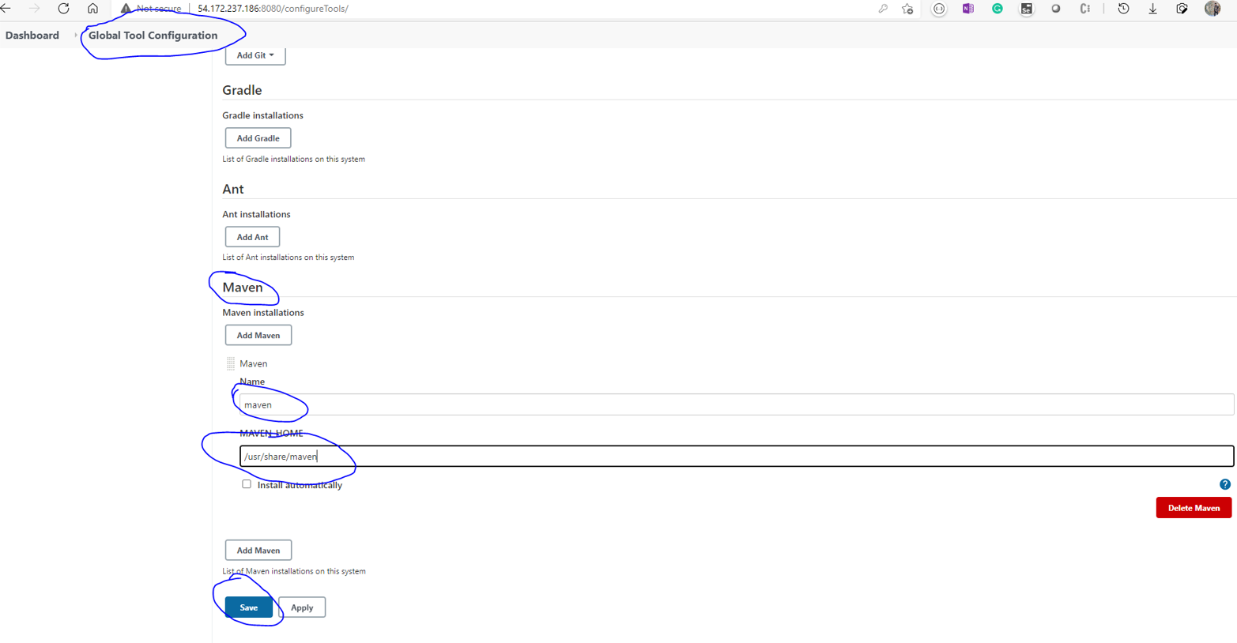

# Pipeline:

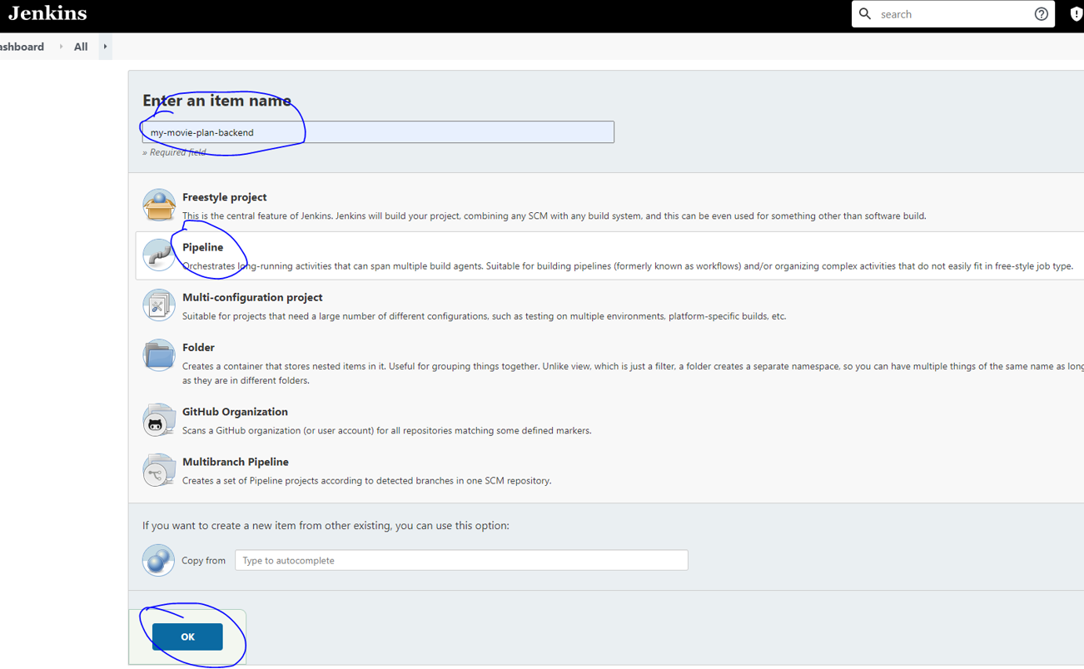

# Triggers:

